HOSPITAL MANAGEMENT SYSTEM

(WEBSITE)

BY

SIDDHESH DINESH DALVI

&

SURAJ NAVNATH KORDE

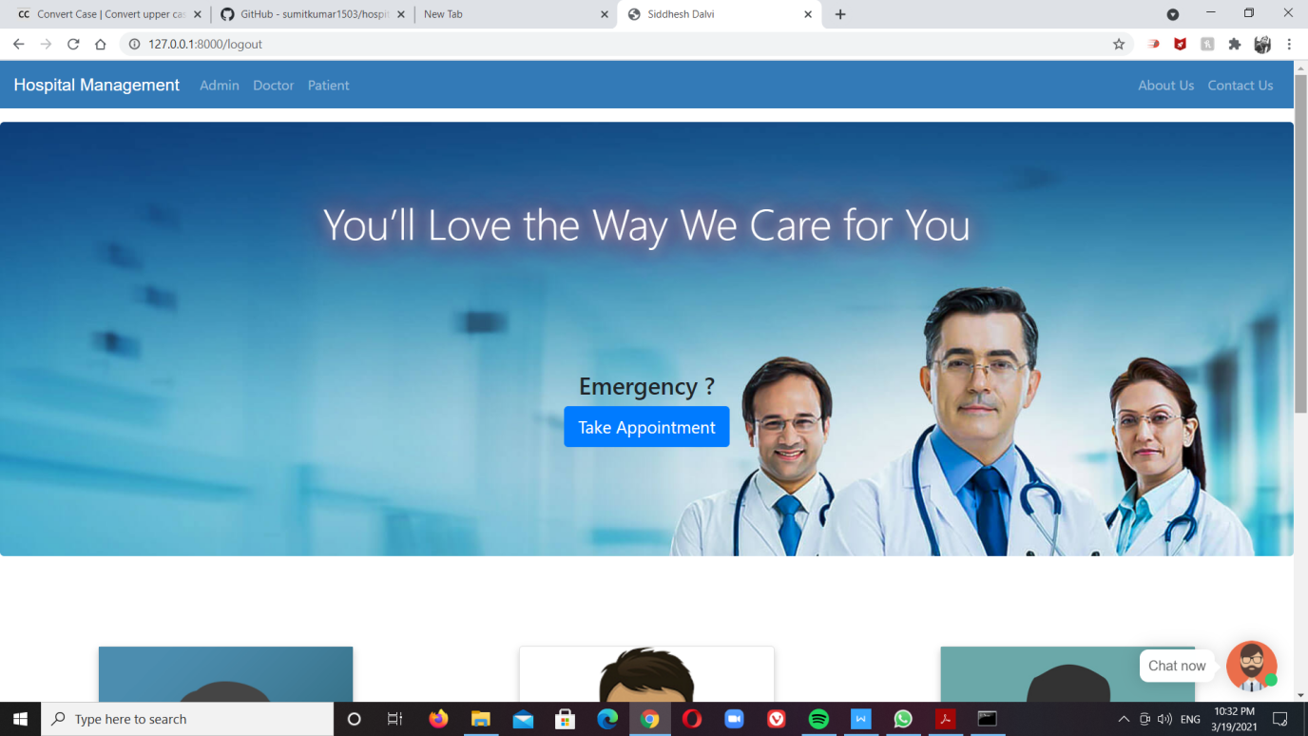

**PROFORMA FOR THE APPROVAL PROJECT PROPOSAL**

PNR No.: 2018016400027776 Seat no.: 3270534

PNR No.: 2018016400032592 Seat no.: 3270539

1. Name of the Student

SIDDHESH DINESH DALVI AND SURAJ NAVNATH KORDE

1. Title of the Project

HOSPITAL MANAGEMENT SYSTEM

1. Name of the Guide

Mrs. ANJU MANRAL

1. Teaching experience of the Guide **12 YEARS**
2. Is this your first submission? Yes No

Signature of the Student Signature of the Guide

Date: ………………… Date: …………………

Signature of the Coordinator

Date: ………………

**HOSPITAL MANAGEMENT SYSTEM**

**A Project Report**

Submitted in partial fulfillment of the

Requirements for the award of the Degree of

**MASTER OF SCIENCE (INFORMATION TECHNOLOGY)**

**By**

**Siddhesh Dalvi (3270534)**

**Suraj Korde (3270539)**

**Under the esteemed guidance of**

**Mrs. Anju Manral**

**Designation**



**DEPARTMENT OF INFORMATION TECHNOLOGY**

**N.G. ACHARYA & D.K. MARATHE COLLEGE OF ARTS, SCIENCE & COMMERCE *(Affiliated to University of Mumbai)*** **MUMBAI-400071 MAHARASHTRA 2022-2023**

**N.G. ACHARYA & D.K. MARATHE COLLEGE OF ARTS, SCIENCE & COMMERCE MUMBAI-400071 MAHARASHTRA**

***(Affiliated to University of Mumbai)***

**DEPARTMENT OF INFORMATION TECHNOLOGY**



**CERTIFICATE**

This is to certify that the project entitled,” **HOSPITAL MANAGEMENT**”, is a combine work of “**Mr. Siddhesh Dinesh Dalvi**” and “**Mr. Suraj Navnath Korde**” Student of N.G. ACHARYA & D.K. MARATHE COLLEGE OF ARTS, SCIENCE & COMMERCE submitted in partial fulfillment of the requirement for the award of degree of MASTER OF SCIENCE in INFORMATION TECHNOLOGY from University of Mumbai.

It is further certified that student completed all required phases of project.

**Internal Guide** : **Coordinator:**

(Prof. Anju Manral) (Prof. Priti Palkar)

**External Examiner**

**DATE** : **College Seal**

**ACKNOWLEGEMENT**

We express our sincere thanks to the principal **Dr. VIDHYAGAURI LELE** also express our thanks to the staff of Information Technology Department. We would like to thanks our Project Guide **Mrs. ANJU MANRAL** and Head of Department **Mrs. PRITI PALKAR** for her encouragement and guidance which helped us in completing the project.

We both immensely grateful to all those because their inspiration, constant prompting and useful suggestions.

We sincerely appreciate the help provided by those in the careful preparation of the project.

Sincere thanks from,

Mr. Siddhesh Dinesh Dalvi

Mr. Suraj Navnath Korde

**TABLE OF CONTENTS**

|  |  |  |  |
| --- | --- | --- | --- |
| Sr.No. | Contents | Page no. | Sign. |
| 1. | INTRODUCTION | 2 |  |
|  | 1.1 Background | 3 |  |
|  | 1.2 Objectives | 4 |  |
|  | 1.3 Purpose, Scope and Applicability | 5 |  |
|  | 1.4 Achievements | 6 |  |
|  | 1.5 Organization of Report | 6 |  |
| 2. | SURVEY OF TECHNOLOGY | 9 |  |
| 3. | REQUIREMENTS AND ANALYSIS | 17 |  |
|  | 3.1 Module Division | 18 |  |
|  | 3.2 Data Dictionary | 20 |  |
|  | 3.3 Entity-Relationship Diagram (E-R) | 25 |  |
|  | 3.4 Data Flow Diagrams | 26 |  |
|  | 3.5 UML Diagram | 29 |  |
| 4. | SYSTEM DESIGN | 35 |  |
|  | 4.1 Basic Modules | 36 |  |
|  | 4.2 Data Design | 37 |  |
|  | 4.2.1 Schema Design | 38 |  |
|  | 4.2.2 Data Integrity and Constraints | 38 |  |
|  | 4.3 Procedural Design | 39 |  |
|  | 4.3.1 Logic Diagrams | 39 |  |
|  | 4.3.2 Data Structures | 39 |  |
|  | 4.3.3 Algorithms Design | 40 |  |
|  | 4.4 User Interface Design | 41 |  |
|  | 4.5 Security Issues | 42 |  |
|  | 4.6 Test Cases Design | 43 |  |

**TABLE OF CONTENTS**

|  |  |  |  |
| --- | --- | --- | --- |
| Sr.No. | Contents | Page no. | Sign. |
| 5. | IMPLEMENTATION AND TESTING | 45 |  |
|  | 5.1 Implementation Approaches | 46 |  |
|  | 5.2 Coding Details and Code Efficiency | 46 |  |
|  | 5.2.1 Code Efficiency | 52 |  |
|  | 5.3 Testing Approach | 53 |  |
|  | 5.3.1 Unit Testing | 53 |  |
|  | 5.3.2 Integrated Testing | 53 |  |
|  | 5.3.3 Beta Testing | 53 |  |
|  | 5.4 Modifications and Improvements | 54 |  |
|  | 5.5 Test Cases | 54 |  |
| 6. | RESULTS AND DISCUSSION | 57 |  |
|  | 6.1 Test Reports | 58 |  |
|  | 6.2 User Documentation | 61 |  |
| 7. | CONCLUSIONS | 65 |  |
|  | 7.1 Conclusion | 66 |  |
|  | 7.1.1 Significance of the System | 66 |  |
|  | 7.2 Limitations of the System | 67 |  |
|  | 7.3 Future Scope of the Project | 68 |  |
| 8. | REFERENCES | 69 |  |
|  |  |  |  |
|  |  |  |  |
|  |  |  |  |
|  |  |  |  |
|  |  |  |  |

**CHAPTER NO. 1**

**INTRODUCTION**

**1.0INTRODUCTION**

The project Hospital Management system includes registration of patients, storing their details into the system, and also computerized billing in the pharmacy, and labs. The software has the facility to give a unique id for every patient and stores the details of every patient and the staff automatically. It includes a search facility to know the current status of each room. User can search availability of a doctor and the details of a patient using the id.

The Hospital Management System can be entered using a username and password. It is accessible either by an administrator or receptionist. Only they can add data into the database. The data can be retrieved easily. The interface is very user-friendly. The data are well protected for personal use and makes the data processing very fast. Hospital Management System is powerful, flexible, and easy to use and is designed and developed to deliver real conceivable benefits to hospitals. Hospital Management System is designed for multi-speciality hospitals, to cover a wide range of hospital administration and management processes.

It is an integrated end-to-end Hospital Management System that provides relevant information across the hospital to support effective decision making for patient care, hospital administration and critical financial accounting, in seamless flow. Hospital Management System is a software product suite designed to improve the quality and management of hospital management in the areas of clinical process analysis and activity-based costing. Hospitals Management System enables you to develop your organization and improve it effectiveness and quality of work. Managing the key processes efficiently is critical to the success of the hospital helps you manage your processes.

* 1. **BACKGROUND**

The hospital management system (HMS) is an integrated software that handles different directions of clinic workflows. It manages the smooth healthcare performance along with administrative, medical, legal and financial control. That is a cornerstone for the successful operation of the healthcare facility.

* A Hospital is a place where Patients come up for general diseases. Hospitals provide facilities like.
* Consultation by Doctors on Diseases.
* Diagnosis for diseases.
* Providing treatment facility.
* Facility for admitting Patients (providing beds, nursing, medicines etc.)
* Immunization for Patients/Children. Various operational works that are done in a Hospital.
* Recording information about the Patients that come.
* Generating bills.
* Recording information related to diagnosis given to Patients.
* Keeping record of the Immunization provided to children/patients.
* Keeping information about various diseases and medicines available to cure them. These are the various jobs that need to be done in a Hospital by the operational staff and Doctors. All these works are done on papers. The work is done as follows.
* Information about Patients is done by just writing the Patients name, age and gender. Whenever the Patient comes up his information is stored freshly.
* Bills are generated by recording price for each facility provided to Patient on a separate sheet and at last they all are summed up.
* Diagnosis information to patients is generally recorded on the document, which contains Patient information. It is destroyed after some time period to decrease the paper load in the office.
* Information about various diseases is not kept as any document. Doctors themselves do this job by remembering various medicines. All this work is done manually by the receptionist and other operational staff and lot of papers are needed to be handled and taken care of.
* Immunization records of children are maintained in pre-formatted sheets, which are kept in a file.
* Diagnosis information to patients is generally recorded on the document, which contains Patient information. It is destroyed after some time period to decrease the paper load in the office**.**

**1.2 OBJECTIVE**

Main objectives of a Hospital Management System are Design a system for better patient care. Reduce hospital operating costs. Provide MIS (Management Information System) report on demand to management for better decision making. Better co-ordination among the different departments. Provide top management a single point of control.

Hospital management System handles activities of major departments in a hospital like:

1. Doctor Management
2. Define hospital
3. Recording information about the Patients that come.
4. Generating bills
5. Recording information related to diagnosis given to Patients.
6. Patient management (scheduling, registration and long-term care)
7. Patient care management and department Management.

Hospital management system can be developed by using waterfall model which is a popular version of development life cycle model for software engineering. It describes a development method that is linear and sequential. It has distinct goals for each phase of development. In this model once, a phase of development is completed, there is no turning back, the development proceeds to the next phase. The advantage of this model is that it allows for departmentalization and managerial control.

**1.3 PURPOSE**

The health system is one of essential socio-economic activities; therefore, it requires rational and effective management. For this, it is necessary to have a tool that allows adequate control of the information generated in health institutions. Hospitals, as the main actors of the health system, generate an essential volume of information, but in most cases, it is dispersed or not available in the necessary time and manner.

In recent years, health information systems have helped improve the quality of life of people in all sectors of our society, so it is inevitable to adhere to this dizzying technological career. Currently, clinical and administrative management of hospitals and health centres is possible through a single platform, with the support of cutting-edge technology, developed to optimize the processes that allow the operation of organizations dedicated to treating patients in any branch of the medicine.

Hospital management systems allows us the ability to optimize and digitize all the processes within the institution, which will help to improve customer service, reduce process costs, streamline the search of medical records, bills, patients, doctors, etc.; thus, having a database of each module implemented.

A hospital management system is a web system developed for companies that wish to manage their processes, implementing modules for each of the required areas. It is essential to mention that the information is controlled by trained personnel. Computer technology is only a tool that allows us to perfect the inveterate use of paper records (notebooks, index cards, diaries, bibliographies, record books), or more recently, cassettes or video cassettes. A PC only collects and processes data; it is the individual that acquires information.

**1.4 SCOPE**

1. Information about Patients is done by just writing the Patients name, age and gender. Whenever the Patient comes up his information is stored freshly.

2. Bills are generated by recording price for each facility provided to Patient on a separate sheet and at last they all are summed up.

3. Diagnosis information to patients is generally recorded on the document, which contains Patient information. It is destroyed after some time period to decrease the paper load in the office.

4. Immunization records of children are maintained in pre-formatted sheets, which are kept in a file.

5. Information about various diseases is not kept as any document. Doctors themselves do this job by remembering various medicines.

All this work is done manually by the receptionist and other operational staff and lot of papers are needed to be handled and taken care of. Doctors have to remember various medicines available for diagnosis and sometimes miss better alternatives as they can’t remember the mattha at time.

**1.5 APPLICABILITY**

Hospital management requires a lot of decision making which is highly difficult if there is no strong management system in place. Since you need precise and accurate implementation at every stage, the automation system in the hospital has to be self-sufficient. Today, it is not possible to imagine a super-specialty hospital without it. A reliable, cost-effective, and efficient system becomes the backbone of the success of a medical centre. There are several benefits of installing full-fledged software.

* **Achieve good quality ratings**

When your hospital wants to be among the top-preferred and high-rated hospitals by insurance companies, there is no escape from hospital management system. Medicare companies and insurance companies rely on electronic data up to a major extent that is possible only when there is an automated system in place. It is one of the critical quality indicators. A hospital that is capable of sending and receiving patient information and medical reports electronically always gets a higher preference over others. A good hospital management system stands out your medical centre, nursing home, or hospital distinctly from competitors. It adds a value to your reputation in the market.

* **Better revenue management**

A hospital or medical centre serves humanity, but profitability is an equally important aspect because it is a business also. Revenue management is a key element because it requires a fortune to run a hospital and. It is impossible to track the same using age-old manual ssystems.

Automated hospital management system that is tailored as per the business requirements can solve the purpose effectively. It offers fast and accurate transactional and management reports that give an instant feel of how the business is doing. What is the outstanding amount, pending invoices, and debts and interests?

Also, there is a reduction in operating costs due to high operational efficiency. When systems and processes are automated, lesser resources are required for managing operations. Thus, improved ROI and fast Break-Even Point can be achieved.

* **Avoid errors and track every single detail**

As stated earlier, managing hospital is a crucial thing where there is no scope for errors. A manual system can’t assure full proof and 100% accurate processing. There are possibilities of errors and mistakes. Installing an automated management system removes the chance of error completely, and you avoid compliance issues and lawsuits, the two biggest hassles for medical centres and hospitals. Thus, in spite of high investment it is a good deal. In addition to it, tracking a minute detail of room occupancy, staff availability, and operational information is available at the fingertips.

* **Improved clinical decision-making**

A good quality management system makes sure that operational and clinical decision-making process is fast, accurate, and efficient. With an easy, single view availability of data points, doctors, and medical support staff gets facilitated.

* **Improve data security**

The fact has been highlighted and reinforced by experts that hospitals that rely on the manual system are more vulnerable to data theft and leakage than automated ones. A full-fledged hospital management system keeps every bit of information secure from unauthorized access. However, it is equally important that you implement a state-of-the-art system with centralized controls and not a standalone home-grown system. When everything is handled by an access-controlled system where availability of information depends on user rights, there is no possibility of error. It is the reason health clinics, hospitals, trauma centres, rehabilitation centres and nursing homes are installing high-quality management ssystem.

* **Establish your hospital as technically advanced**

When a hospital is managed by new-age hospital management system, it gets established as a techno-savvy and modern medical centre. It is highly important in the fiercely competitive modern world that your hospital has a good reputation. Today, people rely on computerized systems more than manual ones. It creates a high level of trust in the systems and processes. Also, it is possible to maintain connectivity with patients and peripheral systems if the operations are managed using automated ssystems.

With the advancement of Information Technology in last few years, there has been a revolutionary change in the automation and management systems available for hospitals. Other than handling mundane operational stuff by business automation modules, they offer intelligent Management Information System as well. An error-free and well-organized module is need of the day!

HM portals are capable of providing a better concerted environment between hospital staff, doctors, groups, patients and managing workflows. Portal solutions even have the ability to unify legacy applications, objects from other portals, and handle multitudes of user requests resulting in an uninhibited flow of information between staffs, doctors and patient.

**CHAPTER NO. 2**

**SURVEY OF TECHNOLOGY**

**2.1 EXISTING SYSTEM**

Hospitals currently use a manual system for the management and maintenance of critical information. The current system requires numerous paper forms, with data stores spread throughout the hospital management infrastructure. Often information is incomplete or does not follow management standards. Forms are often lost in transit between departments requiring a comprehensive auditing process to ensure that no vital information is lost. Multiple copies of the same information exist in the hospital and may lead to inconsistencies in data in various datastores.

The current manual system has a lot of paper work. To maintain the records of sale and service manually, is a Time-consuming task. With the increase in database, it will become a massive task to maintain the database. Requires large quantities of file cabinets, which are huge and require quite a bit of space in the office, which can be used for storing records of previous details. The retrieval of records of previously registered patients will be a tedious task. Lack of security for the records, anyone disarrange the records of your system. If someone want to check the details of the available doctors the previous system does not provide any necessary detail of this type.

**2.2 PROPOSED SYSTEM**

The Hospital Management System is designed for any hospital to replace their existing manual paper-based system. The new system is to control the information of patients. Room availability, staff and operating room schedules and patient invoices. These services are to be provided in an efficient, cost effective manner, with the goal of reducing the time and resources currently required for such tasks.

**2.3 REQUIREMENT ANALYSIS**

We present intelligent agent models for automated requirements gathering for computerized Hospital Management System (HMS). While analysing the hospital management process we discovered that there are several tasks that are being performed independently and for tasks multiple intelligent agents can be created. These agents can be made to gather or sense users' requirements automatically even after the deployment of the HMS if the requirements gathering and the sensing are done through sensing and learning. In this paper we present designs of four such agents. They are: Patient Agent, Doctor Agent, Nurse Agent and Environment Agent.

* **Patient Agent:**

A patient agent simulates the role of patients. The agent helps patients in consultancy about doctor selection according to his need and symptoms. The agent gathers patient’s requirements and prepares a requirement report in the developers’ comprehensible form and sends that to him.

* **Doctor Agent:**

A doctor agent plays the role of a doctor. It’s the main aim is to gather requirements of the doctor such as time saving approaches to deal with the patient and prepare report for developer. A doctor agent also collects the advisory requirements such as suitable treatment and medication for a particular patient.

* **Environment Agent:**

The environment agent is responsible for the hospitality of the hospital. It maintains the arrangement of various hospital units such as wardrooms, ICUs and operating rooms. It is the part of user interface of the computerized HMS. An environment agent senses requirements related to user interface of the HMS software and helps doctors and patients in the selection of various hospital resources such as ICUs, operating rooms, and wardrooms.

All these agents operate in coordination with each other. They are provided with learning abilities so, being a HMS constituent, they learn various requirements while the HMS is in operation. These agents work independently in gathering the requirements from HMS users as well from each other. Moreover, if required they co-operate among various agents and finalize tasks. Needless to say, each intelligent agent generates a report for developers of the HMS for the purpose of enhancing the HMS performance. The complete scenario of agent in action is depicted in Figure 2 below where agents interact with HMS users, among themselves and HMS developers.

**2.4 HARDWARE REQUIREMENTS**

The most common set of requirements defined by any operating system or software application is the physical computer resources, also known as hardware. A hardware requirements list is often accompanied by a hardware compatibility list (HCL), especially in case of operating systems. An HCL lists tested, compatibility and sometimes incompatible hardware devices for a particular operating system or application. The following sub-sections discuss the various aspects of hardware requirements.

HARDWARE REQUIREMENTS FOR PRESENT PROJECT:

PROCESSOR: Intel dual Core, I3

RAM: 1 GB

HARD DISK: 80 GB

**2.5 SOFTWARE REQUIREMENTS**:

Software Requirements deal with defining software resource requirements and pre-requisites that need to be installed on a computer to provide optimal functioning of an application. These requirements or pre-requisites are generally not included in the software installation package and need to be installed separately before the software is installed.

**2.6 JUSTIFICATION OF SELECTION OF TECHNOLOGY**

Our present modern information system makes use of computers for the execution, each of them connected through an optimized network. Healthcare is the most critical aspect of our society, and many health care providers face challenges to offer practical and active services to patients.

Considering a ‘multi-speciality’ hospital, many people enter and exit the hospital in a day and maintaining their records safely is tedious. To reduce this type of burdens and to manage the financial, hospital administration and clinical aspects, Hospital management system came into existence.

Apart from that automating your hospital's processes and implementing them cannot be done too easily, you need an efficient hospital management system to take care of everything that is happening around the labs and hospitals.

If you are ready to implement or go with the hospital management system, make sure you follow these things before making it useful in your hospitals or labs.

1. Processing Speed & Results
2. Cost Effective
3. Reduction in Errors
4. Data Security & Retrieving Ability
5. Improved Patient Care
6. Quality & Compliance

**1. Processing Speed and Results**:

Hospital management system follows the standard operating procedures, and there are no chances for deviation to happen in any of the effective HMS systems. With the implementation of HMS in your labs or hospitals, you will be able to treat patients with a better way and accessing their real-time report and other information regarding the patients, and their past clinical data and more can be done quickly and lead to best patient outcomes. Hospital management system makes employees work more accessible and improve the speed of the complete processes for better results.

**2. Cost Effective:**

HMS information system helps to track and control finances, reduce leakages as well as reduce manual work and therefore there is no requirement of the higher human workforce.

Hospital management system helps to cut down the manual work done by humans in the hospitals especially for the peoples who take care of the record and documentations safely. Hospital management system helps in reducing the human resources costs as most of the work is automated.

Cut down the cost related to storage and other associated requirements. If your hospital is entirely HMS implemented, then your hospital will go paper-free one, it's enough if you maintain the mandatory documents and other related ones in your hospital to comply with the regulation standards.

**3. Reduction in Errors:**

Hospital management system will help in reducing different types of errors that made through interventions like missing billing, operational failure, clinical errors, cost leakages, missing appointments and much more.

Every process on the hospital management system are automated, and there are plenty of tasks provided to the software to perform without the human intervention as well as accurately, this reduces the error significantly.

For example, An IPD patient final bill amount can be easily generated if your hospital enabled of Hospital management system as his reports and other samples bill are already billed and safe under the Patients unique Hospital ID, and therefore the billing executive needs to generate from the system and provide the statement to the patients.

If your hospital is not HMS enabled then you need to go with manual entries which involves too many human errors, so preferring HMS will make your billing section easier, faster, accurate and more transparent.

**4. Data Security and Retrieving Ability:**

In a Hospital management system, they are one of the cloud-based software where everything gets interlinked, and therefore there are no chances for breaches to occur as they have high data security**.**

Evidence-based medicine requires the retrieving ability as well as data ability mandatorily, and this easily achieved through a Hospital management system. If you have Hospital management system on your hospital, then you can easily access the operational, clinical and financial data of your hospitals**.**

**5. Improved Patient Care:**

Enhanced work efficiency and improved patient data access mean faster and better clinical decisions. A clinician orders the solution to implement once he gets the diagnostic report on his hand, so its necessary to have speedier support for receiving the reports rapidly. All departments in the hospitals are interconnected and integrated with this automation, and this enhances the patient care quality as well as the hospital turnovers.

**6. Quality and Compliance:**

Every hospital should send a report of birth, and death occurred, their reasons and related solutions to the NABH accreditation monthly. Its difficult to arrange them manually so preferring the best HMS helps you to send the reports faster and at the right time frame.

Every report is monitored and managed in the Hospital Management System carefully and efficiently for the accurate results.

Every one prefers HMS for their hospitals for coordinated and rapid care, reduced costs, reduced waiting time and readmission, enhanced patient safety and clinical care.

* **CONCEPTUAL MODELS**

**Gantt Chart:**

A Gantt chart is a type of bar chart that illustrates a project schedule, named after its inventor, Henry Gantt (1861–1919), who designed such a chart around the years 1910–1915.[1][2] Modern Gantt charts also show the dependency relationships between activities and the current schedule status.

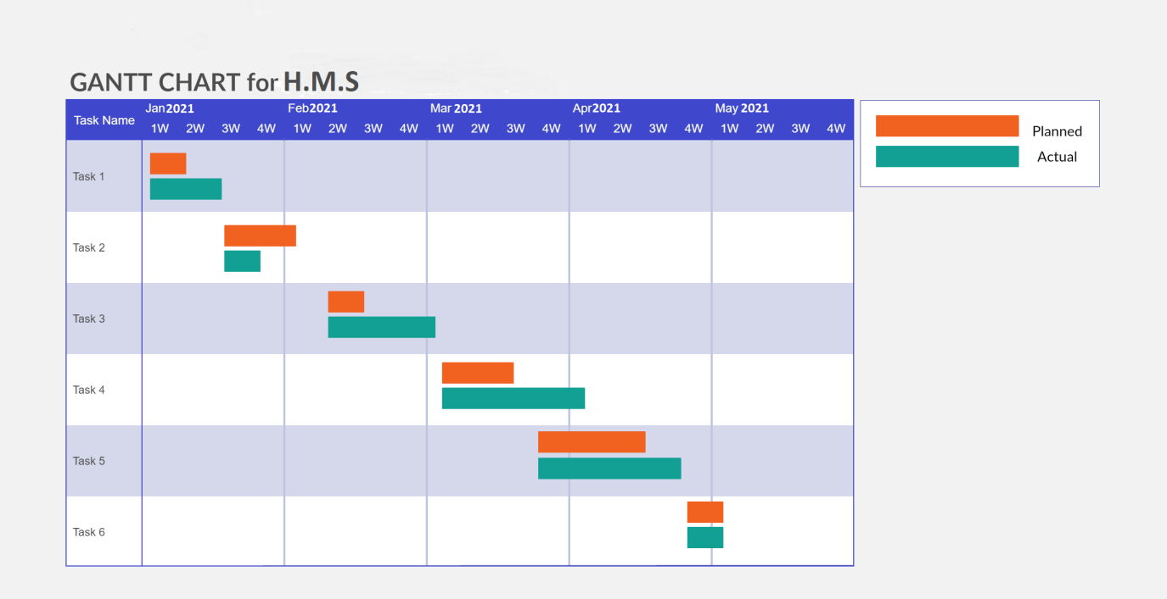

* **pert scheduled diagrams**

The program (or project) evaluation and review technique (PERT) is a statistical tool used in project management, which was designed to analyze and represent the tasks involved in completing a given project.

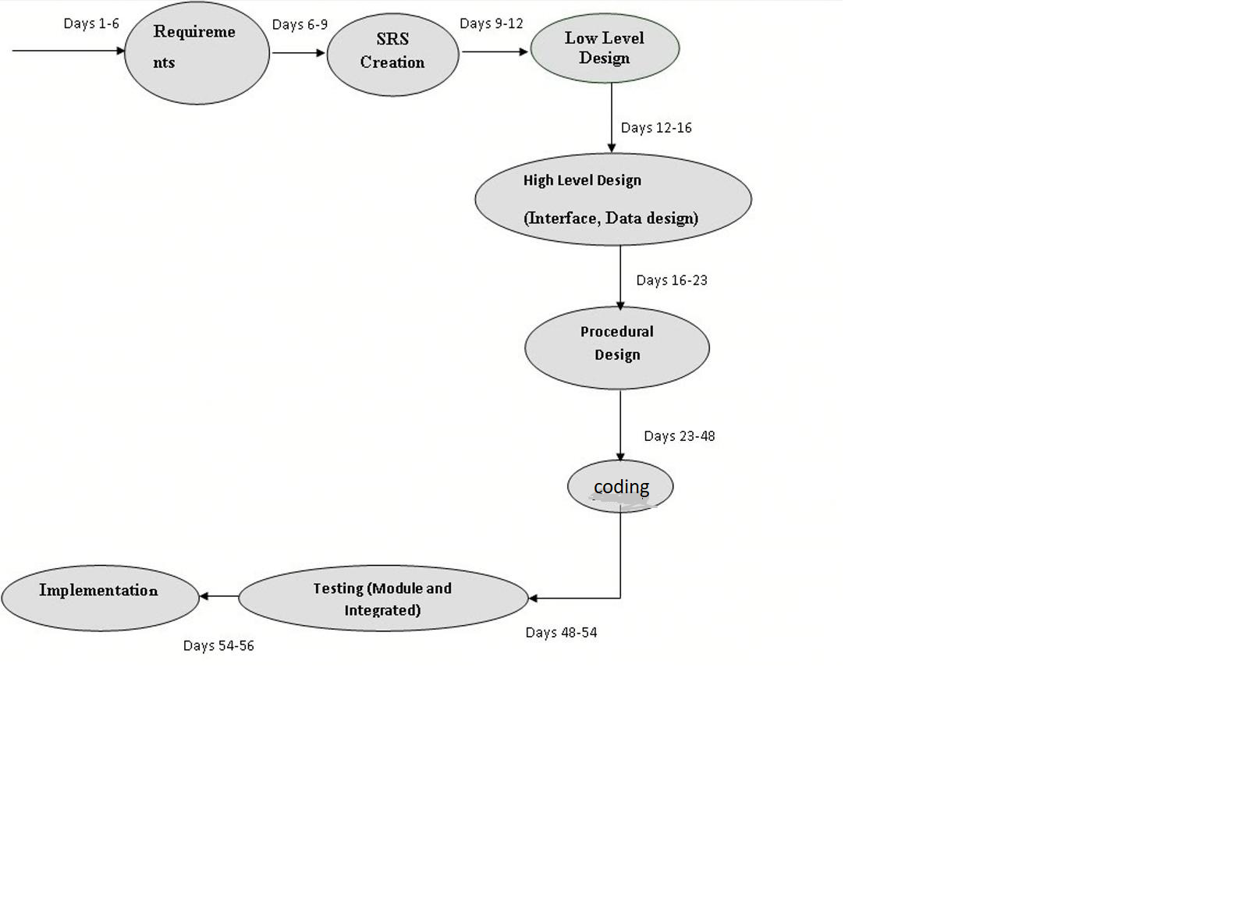

**CHAPTER NO .3**

**REQUIREMENTS AND ANALYSIS**

**3.1 MODULE DIVISION**

**1- Patient Management System:**

Hospital Management System developed by Solution Dots Systems provides complete assistance in patient management. In the module of the patient management system, there is a facility to register patients and view their reports and history. Patient management system allows getting detail information of patient’s health condition**.**

**2- Doctor Management System:**

Doctor Management System allows registering the doctors, working in a hospital as well as their clinic details. It helps in the duty management of doctors and updates them complete appointment details with a patient health history.

**3- Administrative Rights Management System:**

Administrative Rights Management System includes all right of management including HR and administration. This payroll system helps in updating the inventory record as well as all record of payroll management. This is a key element of administration management that manages all purchases and employee management.

**4- Online Appointment Management System:**

Online Appointment Management System allows getting online appointment instead of physical visit. With the help of online appointment management system patient, staff and doctor can check the status of appointment easily. This appointment management system allows to get an appointment for registered patients and also send updates to the customer through SMS or email.

**5- Invoice System:**

After the appointment confirmation Invoice System generates an automatic invoice against that specific patient, this invoice helps to know about the current status of payment as well as complete payment.

**6- Medical Services System:**

Medical Services System allows adding a list of services that are provided by the hospital such as dental treatment service, cardiac services, mental treatment services, bones treatment services and much more. The patient is able to view the list of services and departments offered by the hospital along with all other details of treatment. It also manages the service timing, emergency services according to the condition of the patient.

**7- Doctor Services Report System:**

Doctor Services Report System allows getting complete information and management about the services of doctors. In this report details of doctors such as their specialization field, their work efficiency, and their duty hours and many other details and information could be managed by the management.

**3.2 DATA DICTIONARY**

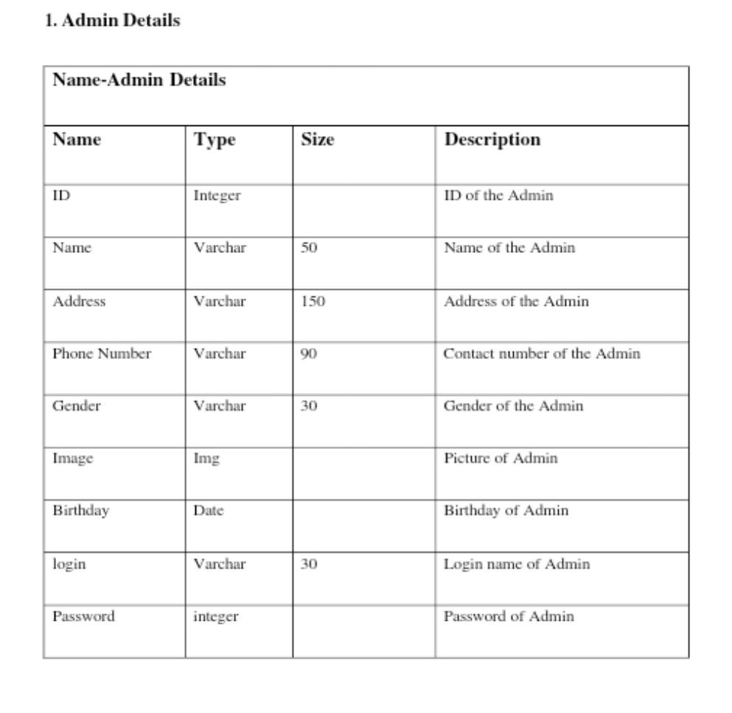

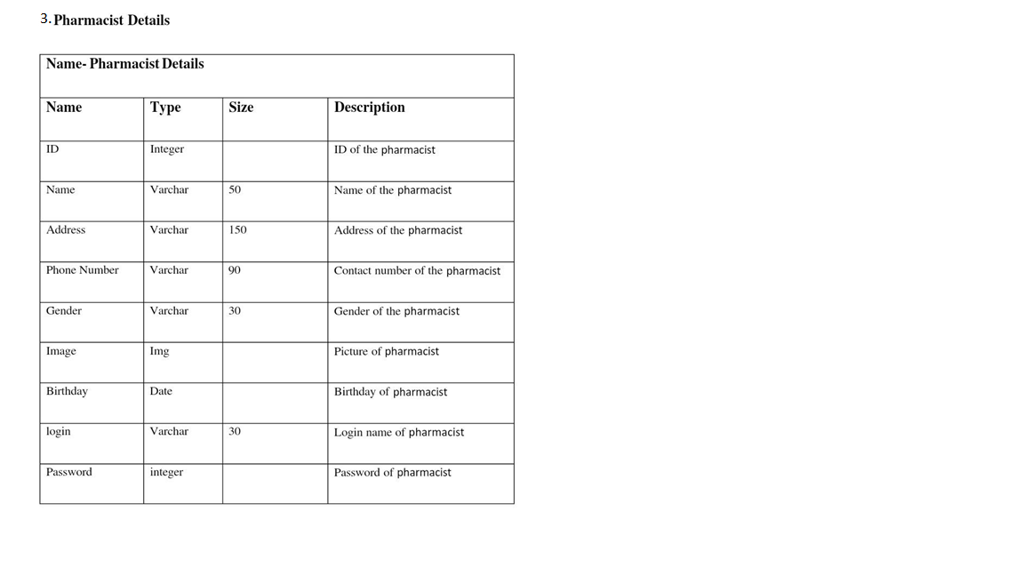

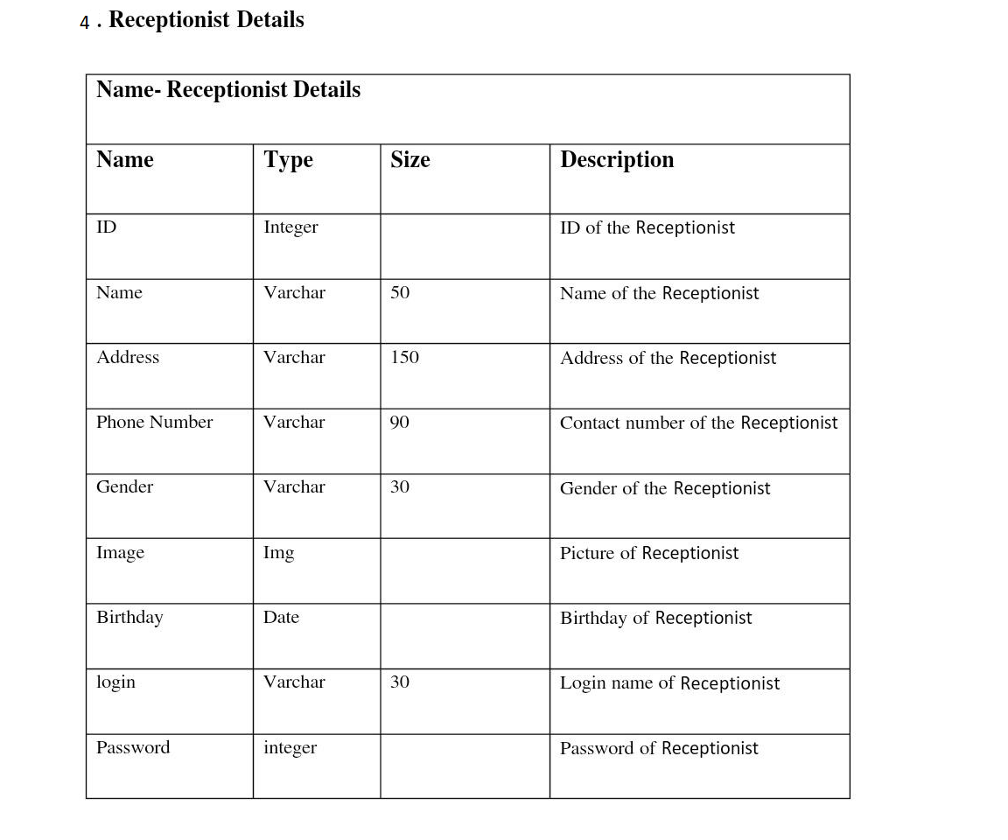

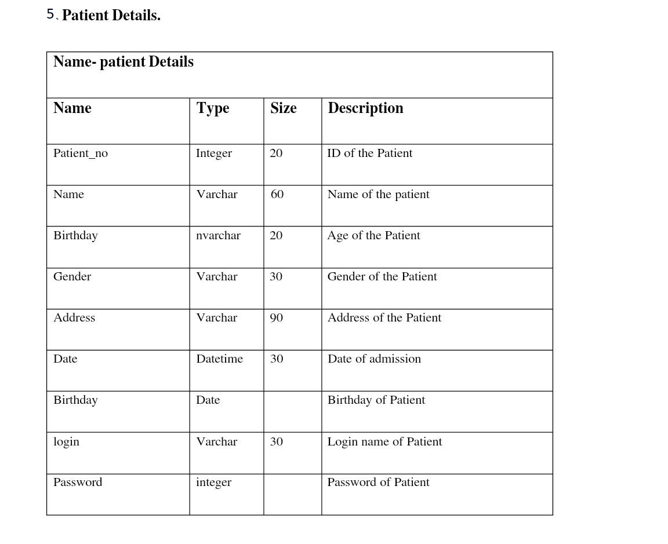

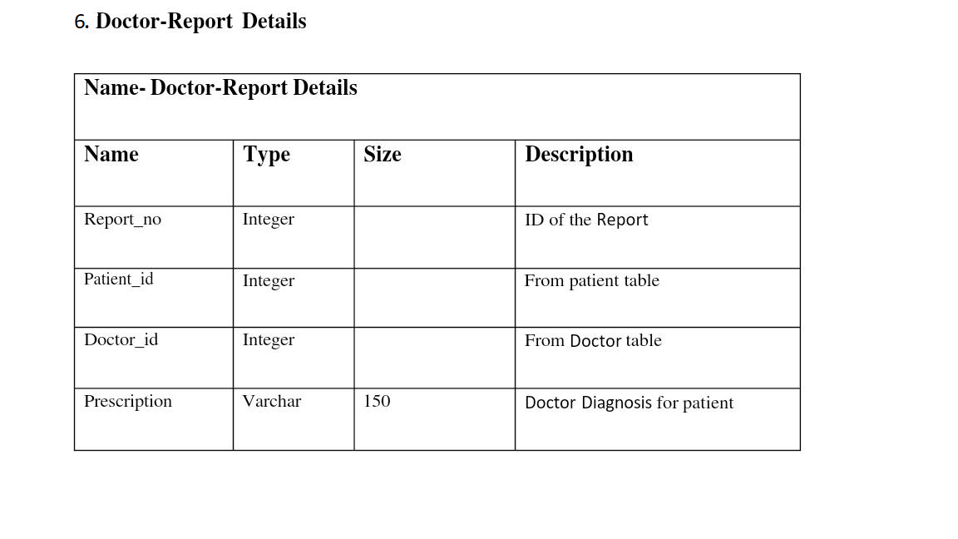

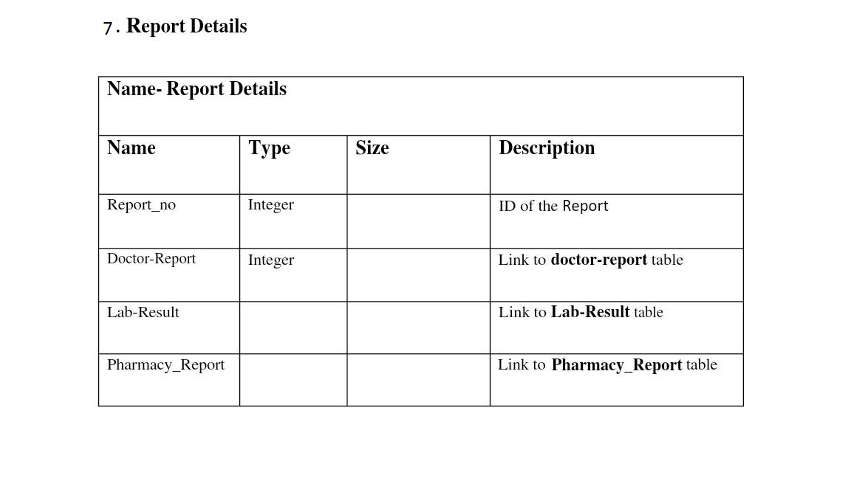3.3 **Entity-Relationship Diagram (E-R)**

Entity-Relationship Diagram is a graphical representation of entities and their relationship to each other’s. It describes how data is related to each other. An entity is a piece of data- an object or a concept about which data is stored. A relationships how the data is shared between entities.

* **In E-R Diagram, there are 3 main**

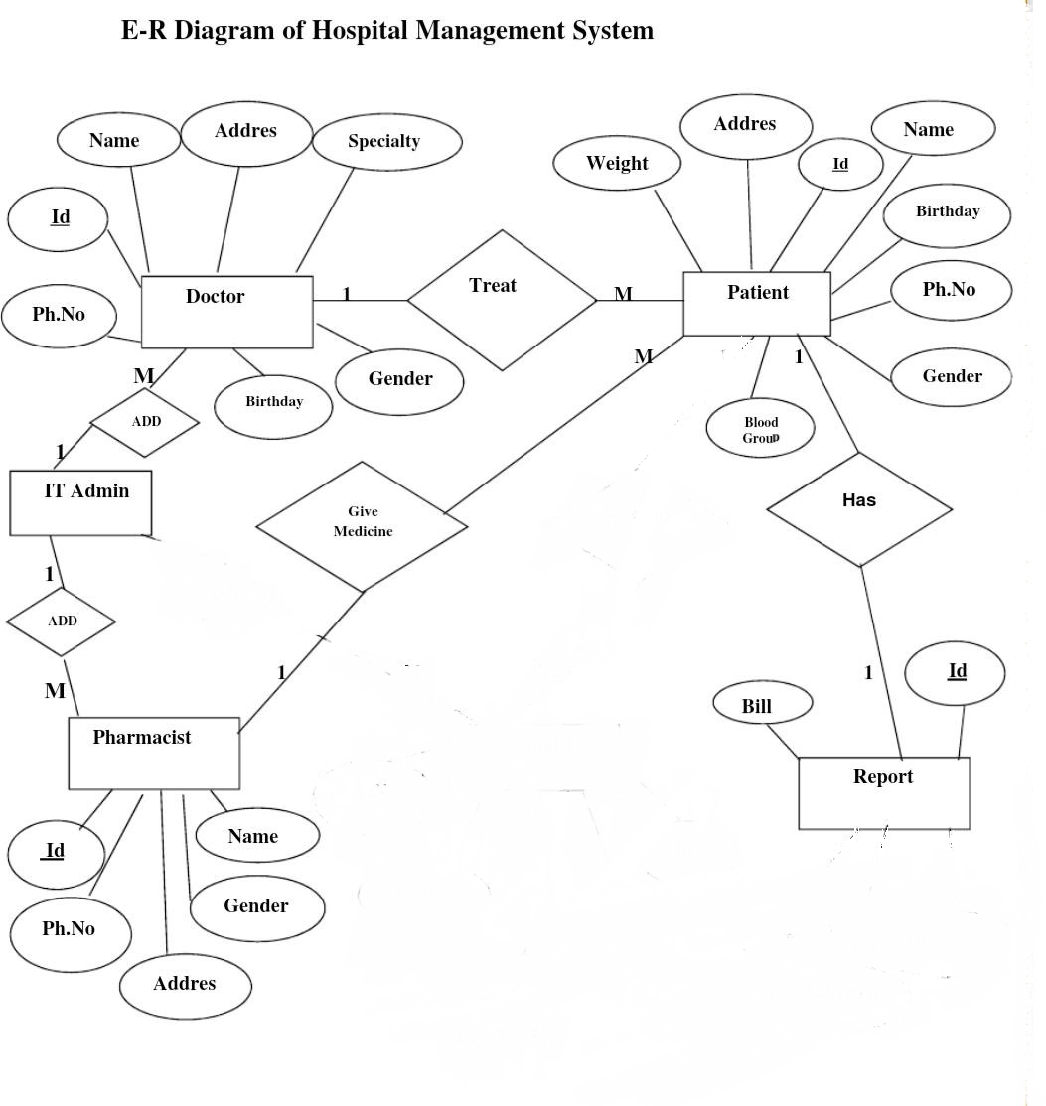

**3.4Data Flow Diagrams**

The Data Flow Diagram (DFD) is a graphical representation of the flow of data through an information system. Data flow diagrams are used by systems analysts to design information-processing systems but also as a way to model whole organizations. The main merit of DFD is that it can provide an overview of what data a system would processes, what transformations of data are done, what data are stored and which stored data is used.

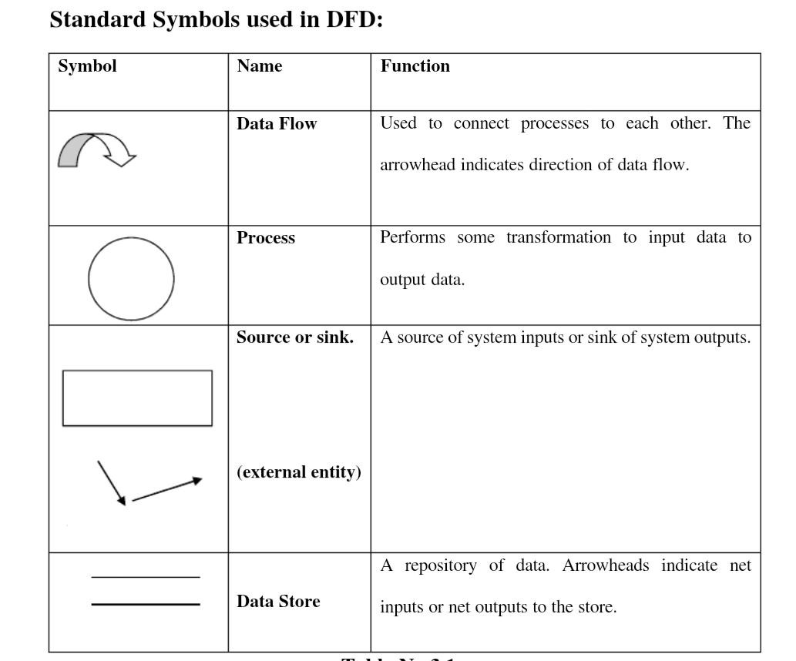

**3.4.0 Level 0 DFD**

A context diagram is a top level (also known as Level 0) data flow diagram. It only contains one process node (process 0) that generalizes the function of the entire system in relationship to external entities. In level 0 DFD, system is shown as one process. The Level 0 DFD shows how the system is divided into 'sub-systems'(processes), each of which deals with one or more of the data flows to or from an external agent, and which together provide all of the functionality of the whole system .and shows the flow of data between the various parts of the system.

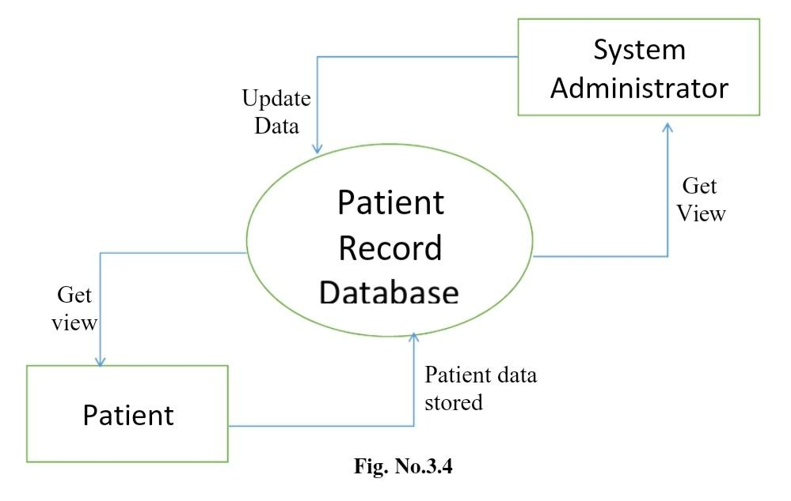

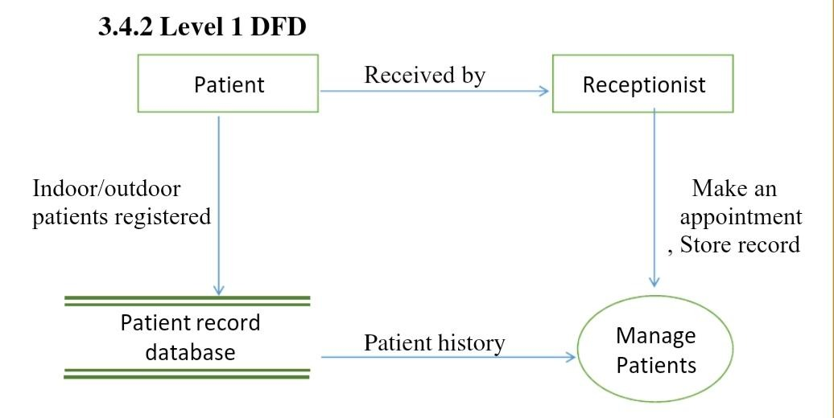

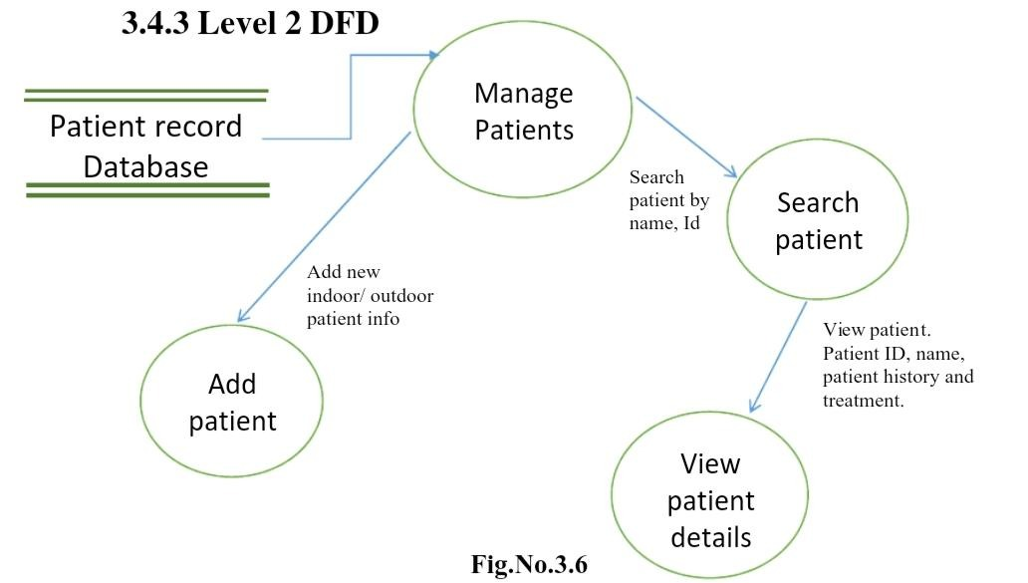

**3.5** **UML Diagram**

**Actor:**

A coherent set of roles that users of use cases play when interacting with the use 'cases'.



**Use case:**

A description of sequence of actions, including variants, that a system performs that yields an observable result or value of an actor.

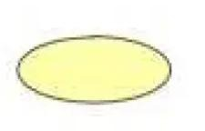

UML stands for Unified Modelling Language. UML is a language for specifying, visualizing and documenting the system. This is the step while developing any product after analysis. The goal from this is to produce a model of the entities involved in the project which later need to be built. The representation of the entities that are to be used in the product being developed need to be designed.

There are various kinds of methods in software design:

* Use case Diagram.
* Sequence Diagram.
* Collaboration Diagram.
* Activity Diagram.
* State chat Diagram.
* **Use case Diagram**

Use case diagram models behaviour within a system and helps the developers understand what the user requires. The stick man represents what's called an actor. Use case diagram can be useful for getting an overall view of the system and clarifying who can do and more importantly what they can't do. Use case diagram consists of use cases and actors and shows the interaction between the use cases and actors.

To represent the system requirements from user's perspective. An actor could be the end-user of the system. A Use case is a description a set of sequence of actions graphically it is rendered as an ellipse with solid line including only its name. Use case diagram is a behavioural diagram that shows a set of use cases and actors and their relationship. It is an association between the use cases and actors. An actor represents a real-world object.

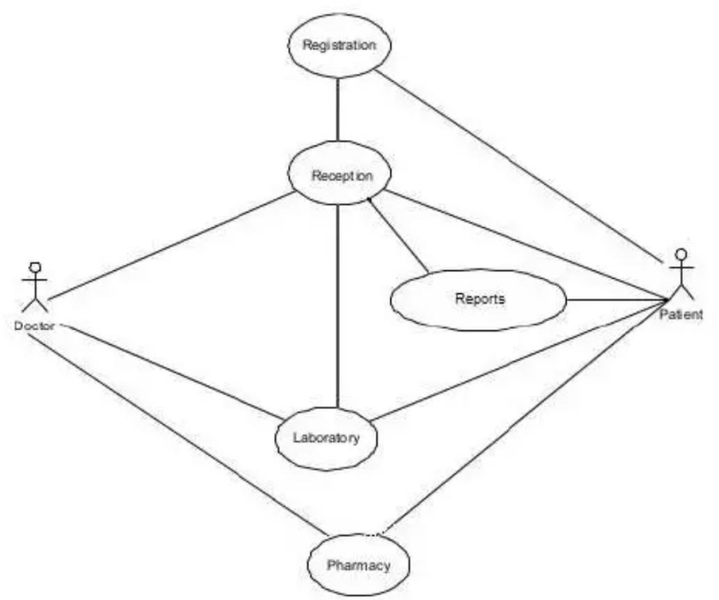

* **Sequence Diagram**

Sequence diagram and collaboration diagram are called INTERACTIONDIAGRAMS. And interaction diagram shows an interaction, consisting of set of objects and their relationship including the messages that may be dispatched among them A sequence diagram is an introduction that empathizes the time ordering of messages. Graphically a sequence diagram is a table that shows objects arranged along the X-axis and messages ordered in increasing time along the Y-axis.

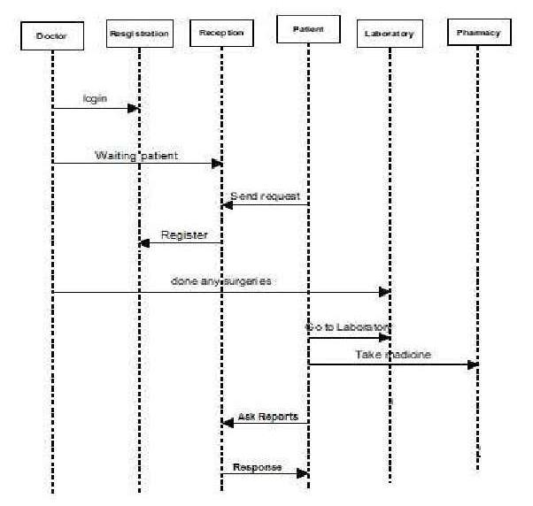

* **COLLABORATION DIAGRAM**

A collaboration diagram is an introduction diagram that emphasizes the structural organization of the objects that send and receive messages. Graphically a collaboration diagram is a collection of vertices and arcs.

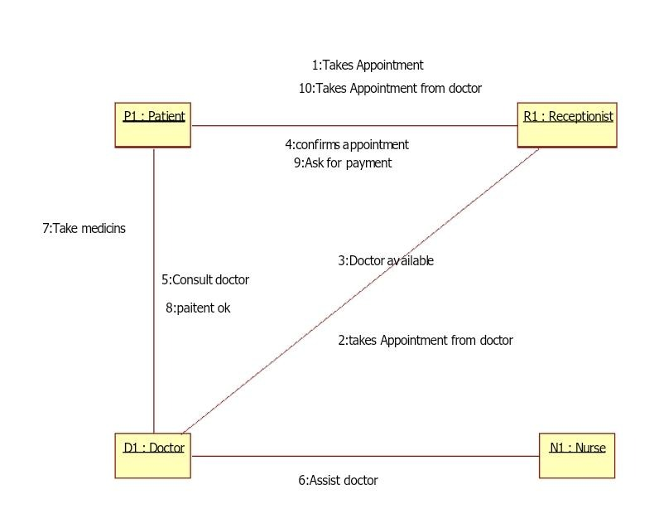

* **Class Diagram**

Class is nothing but a structure that contains both variables and methods. The Class Diagram shows a set of classes, interfaces, and collaborations and their relationships. There is most common diagram in modelling the object oriented systems and are used to give the static view of a system. It shows the dependency between the classes that can be used in our system. The interactions between the modules or classes of our projects are shown below. Each block contains Class Name, Variables and Methods.

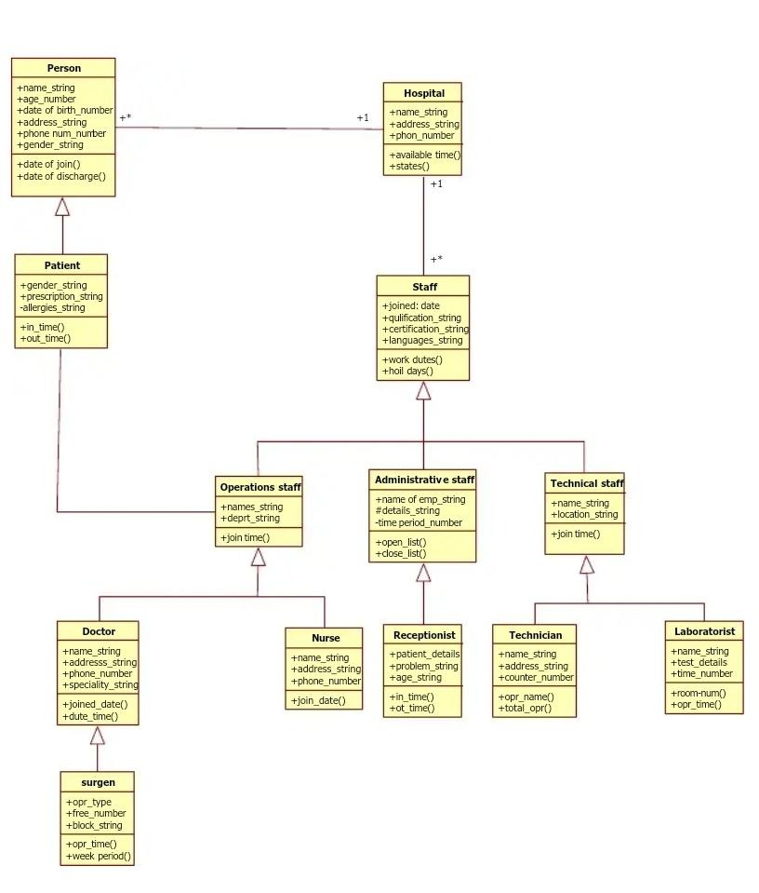

* **Activity diagram**

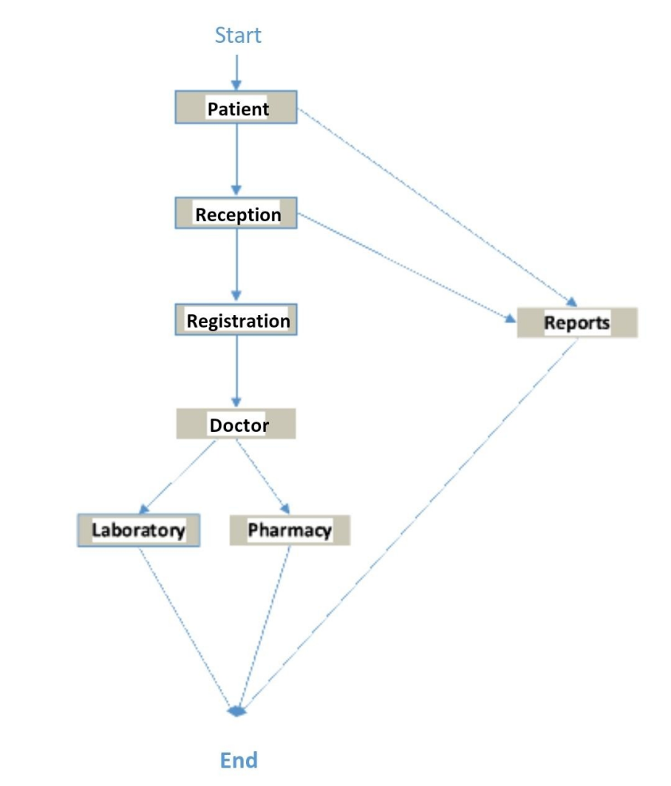

**CHAPTER NO 4**

**SYSTEM DESIGN**

**4.1 BASIC MODULES**

We present intelligent agent models for automated requirements gathering for computerized Hospital Management System (HMS). While analysing the hospital management process we discovered that there are several tasks that are being performed independently and for tasks multiple intelligent agents can be created. These agents can be made to gather or sense users ‘requirements automatically even after the deployment of the HMS if the requirements gathering and the sensing are done through sensing and learning. In this paper we present designs of four such agents.

They are: Patient Agent, Doctor Agent, Nurse Agent and Environment Agent.

• Patient Agent: A patient agent simulates the role of patients. The agent helps patients in consultancy about doctor selection according to his need and symptoms. The agent gathers patient’s requirements and prepares a requirement report in the developers’ comprehensible form and sends that to him.

• Doctor Agent: A doctor agent plays the role of a doctor. It’s the main aim is to gather requirements of the doctor such as time saving approaches to deal with the patient and prepare report for developer. A doctor agent also collects the advisory requirements such as suitable treatment and medication for a particular patient.

• Nurse Agent: A nurse agent plays the role of a nurse. The design of nurse agent is similar to the doctor agent. A nurse agent helps a doctor agent and acts in coordination with doctor agents.

• Environment Agent: The environment agent is responsible for the hospitality of the hospital. It maintains the arrangement of various hospital units such as wardrooms, ICUs and operating rooms. It is the part of user interface of the computerized HMS. An environment agent senses requirements related to user interface of the HMS software and helps doctors and patients in the selection of various hospital resources such as ICUs, operating rooms, and wardrooms.

All these agents operate in coordination with each other. They are provided with learning abilities so, being a HMS constituent, they learn various requirements while the HMS is in operation. These agents work independently in gathering the requirements from HMS users as well from each other.

Moreover, if required they co-operate among various agents and finalize tasks. Needless to say, each intelligent agent generates a report for developers of the HMS for the purpose of enhancing the HMS performance. The complete scenario of agent in action is depicted in Figure 2 below where agents interact with HMS users, among themselves and HMS developers.

**4.2 DATA DESIGN**

Hospital management system database design is uploaded in this page. A database is a collection of information and is systematically stored in tables in the form of rows and columns. The table in the database has unique name that identifies its contents. The database in turn is further described in detail giving all the fields used with the data types, constraints available, primary key and foreign key.

Database design is used to manage large bodies of information. In this database we describe all the 4 tables available in the software, which are used to store all the records.

Data types and its description:

Fields in database table have a data type. Some of the data types used in database table are explained below.

A) Integer: -

One optional sign character (+ or -) followed by at least one digit (0-9). Leading and trailing blanks are ignored. No other character is allowed.

B) Varchar: -

It is used to store alpha numeric characters. In this data type we can set the maximum number of characters up to 8000 ranges by default SQL server will set the size to 50 characters large.

C) Date/Time: -

Date/Time data type is used for representing data or time.

**4.2.1 SCHEMA DESIGN**

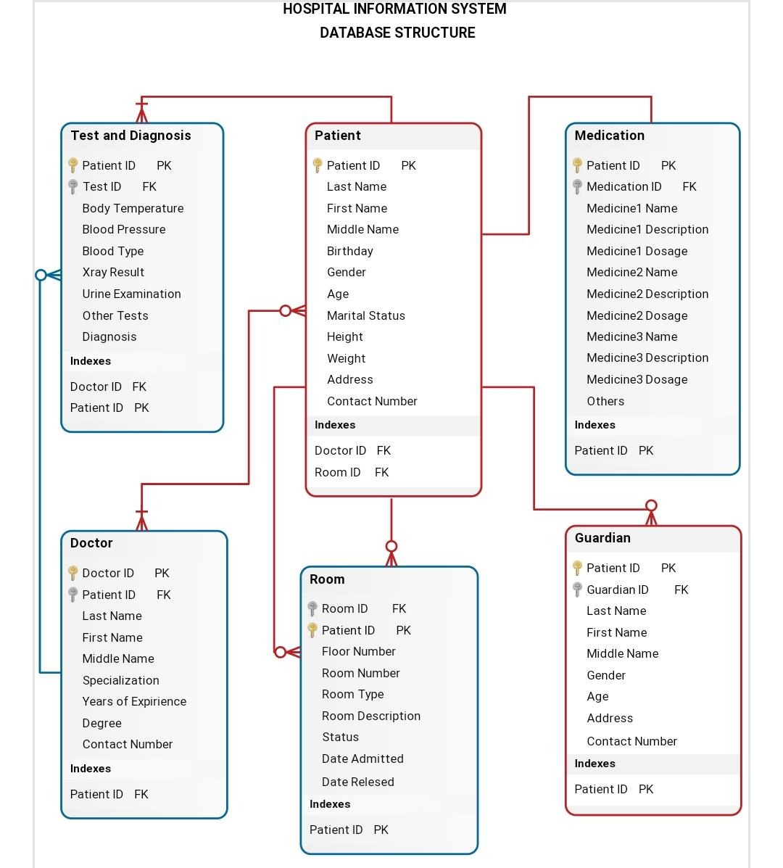

**4.2.2 DATA INTEGRITY AND CONSTRAINTS**

Data integrity is normally enforced in a database system by a series of integrity constraints or rules. Three types of integrity constraints are an inherent part of the relational data model: entity integrity, referential integrity and domain integrity.

Entity integrity concerns the concept of a primary key. Entity integrity is an integrity rule which states that every table must have a primary key and that the column or columns chosen to be the primary key should be unique and not null.

Referential integrity concerns the concept of a foreign key. The referential integrity rule states that any foreign-key value can only be in one of two states. The usual state of affairs is that the foreign-key value refers to a primary key value of some table in the database. Occasionally, and this will depend on the rules of the data owner, a foreign-key value can be null. In this case, we are explicitly saying that either there is no relationship between the objects represented in the database or that this relationship is unknown.

Domain integrity specifies that all columns in a relational database must be declared upon a defined domain. The primary unit of data in the relational data model is the data item. Such data items are said to be non-decomposable or atomic. A domain is a set of values of the same type. Domains are therefore pools of values from which actual values appearing in the columns of a table are drawn.

User-defined integrity refers to a set of rules specified by a user, which do not belong to the entity, domain and referential integrity categories.

**4.3 PROCEDURAL DESIGN**

**4.3.1 DATA STRUCTURES**

Django data MVT Structure

Django is based on MVT (Model-View-Template) architecture. MVT is a software design pattern for developing a web application.

* **MVT Structure has the following three parts** –

**Model**: Model is going to act as the interface of your data. It is responsible for maintaining data. It is the logical data structure behind the entire application and is represented by a database (generally relational databases such as MySQL, Postgres). To check more, visit – Django Models.

**View**: The View is the user interface — what you see in your browser when you render a website. It is represented by HTML/CSS/JavaScript and Jinja files. To check more, visit – Django Views.

**Template**: A template consists of static parts of the desired HTML output as well as some special syntax describing how dynamic content will be inserted. To check more, visit – Django Templates.

A Django Project when initialised contains basic files by default such as manage.py, view.py, etc. A simple project structure is enough to create a single page application. Here are the major files and their explanations. Inside the geeks site folder (project folder) there will be following files.

manage.py-This file is used to interact with your project via the command line (start the server, sync the database… etc). For getting the full list of command that can be executed by manage.py type this code in the command window.

init.py – It is python package.

settings.py – As the name indicates it contains all the website settings. In this file we register any applications we create, the location of our static files, database configuration details, etc.

urls.py – In this file we store all links of the project and functions to call.

wsgi.py – This file is used in deploying the project in WSGI. It is used to help your Django application communicate with the web server.

**4.3.3 ALORITHMS DESIGN**

STEP 1: START.

STEP 2: OPEN REGISTRATION PAGE.

STEP 3: ALLOCATE MEMORY FOR NEW PATIENT INFORMATION.

STEP 4: ENTER INFORMATION.

STEP 5: CREATE UNIQUE PATIENT ID.

STEP 6: CREATE USERNAME AND PASSWORD.

STEP 7: CREATE ENTRY TO THE DATABASE.

STEP 8: ALLOCATE DOCTOR FOR THE PATIENT.

STEP 9: TESTS AND REPORTS ENTRY.

STEP 10: INITIATE ADVANCE FEES.

STEP 11: ALLOCATION OF BED AND ROOM FOR PATIENT.

STEP 12: PATIENT HEALTH PROGRESS.

STEP 13: PATIENT DISCHARGE.

STEP 14: PENDING FEES AND UPDATION.

STEP 15: END.

**4.3.4 USER INTERFACE DESIGN**

* **Homepage**

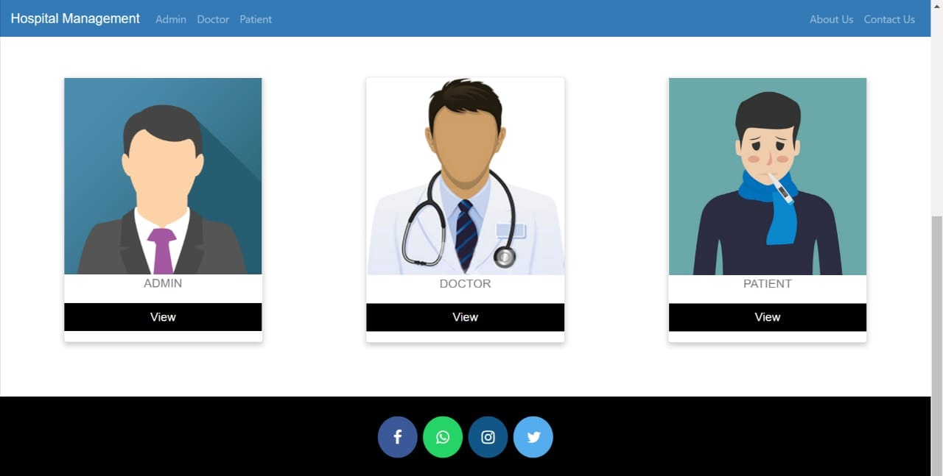\

### Admin Dashboard

### 

### Invoice

### 

### Doctor list

### 

**4.5 SECURITY ISSUES**

Overview of Data Security Issues in Hospital Information Systems / Masrom and Rahilly Pacific Asia Journal of the Association for Information Systems adequate articles. that related to the topic, then we analyse the articles by separating, connecting, comparing, selecting and describing them. Finally, we discussing and synthesizing the previous researches to reach to the result. For writing, the results derived from each article then summarized as findings of this study. Data Security Issues Data security is a eld complex fit deals with several issues and problems, and provides several solutions as a security and privacy can threaten in the several ways. Solutions normally lead to obstructions in normal use.

A global preserving and security solution have to begin with security guideline, security rules and set of the internal privacy definition. These rules must exactly define where the physical place of data is in each stage of lifecycle and they specify how to treat the sensitive data, where it can appear. At the end, patient education is so essential, they should know how the security protecting work and they know about how to resist about the attacker. Data and information security should protect data and information from first stage that data and information create until the last stage, final disposal of the data and information. During the lifetime, the data and information transfer to the several processing systems and in each processing system the data and information can be threat, therefore in order to protect data and information, each processing stage need to provide protection mechanism. The main goal of data security in HIS is to achieve patient safety and privacy. Patient safety means provide best opportunity for patient to come with right information at the right time, and patient privacy mean protecting the sensitive patient data and information from unauthorized person.

The system must protect from attacker and any unauthorized access with implementing strong identification and authentication mechanism. Therefore, the system must guarantee that every user can only access to the data and information, which is permitting to them. Security in HIS is important area that lead to enhance the patient confidently and also lead to public interest to use HIS, while the security in HIS is not fully consider to achieve these goals and several studies are still need in this area. Many studies investigated on the clinic privacy and data security, they found that security vulnerabilities in HIS and in continue they mentioned, considering to security vulnerabilities can be more effectiveness in the security control of HIS. This system is very useful, but depends on security of system. That Solve the existing issues and problems in HIS and cloud computing can bring several benefits for HIS and lead to rapidly progress, while security in cloud computing is a main barrier to adopting in cloud computing for HIS.

**4.6 TEST CASES DESIGN**

* **Test Cases for Hospital Management System**

1. Verify that the portal for new patient registration has all the mandatory fields required for registering a patient.
2. Verify that after filling the patient details and successful payment a Patient-Card is printed.
3. Verify that card has information like patient details, doctor assigned, department, the application number, DOJ, bed allocated (if applicable) etc.
4. Verify that after patient check-up based on the requirement the details are updated in the patient details database.
5. Verify that for existing patients based on the application number of the patient, their records are added/updated in the database.
6. Verify that the system has an admin for doctors as well.
7. Verify that for each doctor’s details like their timings, specialty, fee, patient visited etc is visible to the authorized users.
8. Verify that new details of new doctors can be added to the system.
9. Verify that the details of existing users can be updated in the system.
10. Verify that the doctor’s record can be deleted from the system.
11. Verify the billing admin of the system calculates the bill based on the patient’s unique application number from the data generated from different systems.
12. Verify that the hard copy of the bill can be generating by printing the bill.
13. Verify that authorized users can also see total day-wise billing done.
14. Verify the admin for hospital inventory, room and bed management.
15. Verify that the admin has the record of all the equipment, machines and medicines and the same gets updated when used or added to the system.
16. Verify that the admin has a record of rooms and beds availability and the same gets updated based on their allotment and departure to patients.

**CHAPTER NO .5**

**IMPLEMENTATION AND TESTING**

**5.1 IMPLEMENTATION APPROACHES**

we know, creating software is one thing and the implementation of the created software is another. The process of implementing software is much difficult as compared to the task of creating the project. First, we have to implement the software on a small scale for removing the bugs and other errors in the project and after removing them we can implement the software on a large scale. Before we think in terms of implementing the Software on a large basis, we must consider the Hardware requirements. Whenever we develop software or project a certain hardware and software is being used by the programmer for developing the project. The hardware and software to be used by the programmer for developing the project should be such that it would result in the development of a project, which would satisfy all the basic needs for which the project

79. has been created by the programmer. The Hardware should be such that cost constraints of the Client should also be taken into account without affecting the performance.

**5.2 CODING DETAIL AND CODE EFFICIENCY**

Django settings forhospital management project.

Generated by 'django-admin startproject' using Django 3.0.5.

For more information on this file, see

https://docs.djangoproject.com/en/3.0/topics/settings/

For the full list of settings and their values, see

https://docs.djangoproject.com/en/3.0/ref/settings/

"""

import os

# Build paths inside the project like this: os.path.join(BASE_DIR, ...)

BASE_DIR = os.path.dirname(os.path.dirname(os.path.abspath(_file_)))

TEMPLATE_DIR = os.path.join(BASE_DIR,'templates')

STATIC_DIR=os.path.join(BASE_DIR,'static')

# Quick-start development settings - unsuitable for production

# See https://docs.djangoproject.com/en/3.0/howto/deployment/checklist/

# SECURITY WARNING: keep the secret key used in production secret!

SECRET_KEY = 'hpbv()ep00boce&o0w7z1h)st148(*m@6@-rk$nn)(n9ojj4c0'

# SECURITY WARNING: don't run with debug turned on in production!

DEBUG = True

ALLOWED_HOSTS = []

# Application definition

INSTALLED_APPS = [

'django.contrib.admin',

'django.contrib.auth',

'django.contrib.contenttypes',

'django.contrib.sessions',

'django.contrib.messages',

'django.contrib.staticfiles',

'hospital',

'widget_tweaks',

]

MIDDLEWARE = [

'django.middleware.security.SecurityMiddleware',

'django.contrib.sessions.middleware.SessionMiddleware',

'django.middleware.common.CommonMiddleware',

'django.middleware.csrf.CsrfViewMiddleware',

'django.contrib.auth.middleware.AuthenticationMiddleware',

'django.contrib.messages.middleware.MessageMiddleware',

'django.middleware.clickjacking.XFrameOptionsMiddleware',

]

ROOT_URLCONF = 'hospitalmanagement.urls'

TEMPLATES = [

{

'BACKEND': 'django.template.backends.django.DjangoTemplates',

'DIRS': [TEMPLATE_DIR,],

'APP_DIRS': True,

'OPTIONS': {

'context_processors': [

'django.template.context_processors.debug',

'django.template.context_processors.request',

'django.contrib.auth.context_processors.auth',

'django.contrib.messages.context_processors.messages',

],

},

},

]

WSGI_APPLICATION = 'hospitalmanagement.wsgi.application'

# Database

# https://docs.djangoproject.com/en/3.0/ref/settings/#databases

DATABASES = {

'default': {

'ENGINE': 'django.db.backends.sqlite3',

'NAME': os.path.join(BASE_DIR, 'db.sqlite3'),

}

}

# Password validation

# https://docs.djangoproject.com/en/3.0/ref/settings/#auth-password-validators

AUTH_PASSWORD_VALIDATORS = [

{

'NAME': 'django.contrib.auth.password_validation.UserAttributeSimilarityValidator',

},

{

'NAME': 'django.contrib.auth.password_validation.MinimumLengthValidator',

},

{

'NAME': 'django.contrib.auth.password_validation.CommonPasswordValidator',

},

{

'NAME': 'django.contrib.auth.password_validation.NumericPasswordValidator',

},

]

# Internationalization

# https://docs.djangoproject.com/en/3.0/topics/i18n/

LANGUAGE_CODE = 'en-us'

TIME_ZONE = 'UTC'

USE_I18N = True

USE_L10N = True

USE_TZ = True

# Static files (CSS, JavaScript, Images)

# https://docs.djangoproject.com/en/3.0/howto/static-files/

STATIC_URL = '/static/'

STATICFILES_DIRS=[STATIC_DIR,]

MEDIA_ROOT=os.path.join(BASE_DIR,'static')

LOGIN_REDIRECT_URL='/afterlogin'

#for contact us give your Gmail id and password

EMAIL_BACKEND ='django.core.mail.backends.smtp.EmailBackend'

EMAIL_HOST = 'smtp.gmail.com'

EMAIL_USE_TLS = True

EMAIL_PORT = 587

EMAIL_HOST_USER = 'dalvsiddhesh3@gmail.com' # this email will be used to send emails

EMAIL_HOST_PASSWORD = 'ilovesrushti777' # host email password required

# now sign in with your host gmail account in your browser

# open following link and turn it ON

# https://myaccount.google.com/lesssecureapps

# otherwise you will get SMTPAuthenticationError at /contactus

# this process is required because google blocks apps authentication by default

EMAIL_RECEIVING_USER = ['dalvisiddhesh3@gmail.com'] # email on which you will receive messages sent from website

**5.2.1 CODE EFFICIENCY**

Code efficiencyplays a significant role in applications in a high-execution-speed environment where performance and scalability are paramount.

One of the recommended best practices in coding is to ensure good code efficiency. Well-developed programming codes should be able to handle complex algorithms.

Recommendations for code efficiency include:

To remove unnecessary code or code that goes to redundant processing

To make use of optimal memory and non-volatile storage

To ensure the best speed or run time for completing the algorithm

To make use of reusable components wherever possible

To make use of error and exception handling at all layers of software, such as the user interface, logic and data flow

To create programming code that ensures data integrity and consistency

To develop programming code that's compliant with the design logic and flow

To make use of coding practices applicable to the related software

To optimize the use of data access and data management practices

To use the best keywords, data types and variables, and other available programming concepts to implement the related algorithm

**5.3.1 Unit Testing**

This is the smallest testable unit of a computer system and is normally tested using the white box testing. The author of the programs usually carries out unit tests. In the unit testing the analyst tests the program making up a system. The software units in a system are the modules and routines that are assembled and integrated to perform a specific function. In a large system, many modules on different levels are needed. Unit testing can be performed from the bottom up starting with the smallest and lowest level modules and proceeding one at a time. For each module in a bottom-up 70

71. testing, a short program executes the module and provides the needed data. In integration testing,. In the unit testing the analyst tests the program making up a system. The software units in a system are the modules and routines that are assembled and integrated to perform a specific function. In a large system, many modules on different levels are needed. Unit testing can be performed from the bottom up starting with the smallest and lowest level modules and proceeding one at a time. For each module in a bottom-up testing, a short program executes the module and provides the needed data. Each module tastefully performs as expected.

**5.3.2 Integration Testing**

In integration testing, the different units of the system are integrated together to form the complete system and this type of testing checks the system as whole to ensure that it is doing what is supposed to do. The testing of an integrated system can be carried out top-down, bottom-up, or big-bang. In this type of testing, some parts will be tested with white box testing and some with black box testing techniques. This type of testing plays very important role in increasing the systems productivity. We have checked our system by using the integration testing techniques.

**5.3.3 Beta Testing**

These forms of testing are adopted at the development and pre-release stages and involve the testing of regulatory requirements and production readiness.

beta testing the testing of a vendor’s product—a device, equipment, hardware or software—by applications-knowledgeable users who are familiar with the product’s uses or potential uses. BT is usually performed on-site under the same working conditions for which it was designed, in order to identify and resolve potential problems associated with its use. BT provides both a different perspective and a real-world example of the product’s performance under working conditions, as it will be put through various unanticipated uses and applications. BT has the advantage to an end-user of being at the forefront of a technology, and allows the user to add specific features in the marketed version of the product.

**5.4 MODIFICATION AND IMPROVEMENT**

FUTURE ENHANCEMENTS This application avoids the manual work and the problems concern with it. It is an easy way to obtain the information regarding the various travel services that are present in our System. Well, I and my team member have worked hard in order to present an improved website better than the existing one’s regarding the information about the various activities. Still, we found out that the project can be done in a better way. Primarily,

In this system patient login and then go to reception. By using this patient will send request for consulting the doctor. Reception will set the date for doctor appointments. After that doctor see his appointments and see the patients, surgeries also done. The next enhancement is, we will develop online services. That mean, if patient have any problems, he can send his problem to the doctor through internet from his home then doctor will send reply to him. In these patients have some login name and password.

In order to create the hospital management system feature list, you need to identify your priorities by choosing the benefits that are prior for your case.

Improved Processes. ...

Digital medical records. ...

Staff interaction. ...

Facility management. ...

Financial control and tax planning. ...

Market strategy. ...

Insurance claims processing.

**5.5 Test Cases**

* Check by entering the correct URL in the browser, and the application should be loading properly
* Check is there any user verification functionality present on the application.
* Check by entering valid credential like username and password user should be able to log in
* Check by entering invalid credentials the user should not be login into the application, and an error message should be displayed
* Check is the hospital management system application has an option to add a new patient
* Check whether all the mandatory fields are present registration portal
* Check after adding a new patient, and after completion of the payment process, the patient cards should be printed
* Check whether the patient card has the details like assign doctor name comma department, present application number command date of join and also located bed details, etc
* Check after completion of patient checkup process the details should be updated in the patient database
* Check if the patient exists in the database, and he performs some checkup then the user should be able to search the details of the present in the database
* Check is the doctors are also able to update the passenger details after check
* Check the number of roles in the hospital management system like the patient, doctor, admin, accountant, etc
* Check that the authorized users can see the doctor details in the portal like the doctors’ timings and fees.
* Check if there is any functionality to add a new doctor in the hospital management system, for instance, we have added patient details in the database
* Check whether the admin users can delete doctor and patient information by the hospital management system portal
* Check whether an accountant user type can calculate the bills for patients by collecting data from different systems.
* Check after the formation of a bill that should be an option to print the bill or to generate a hard copy of the bill.
* Check the authorized users have the privilege to check the details report of the patients like day wise
* Check the admin has all the access

**CHAPTER NO .6**

**RESULT AND DISCUSSION**

* **RESULT**

Since we are entering details of the patients electronically in the” Hospital Management System”, data will be secured. Using this application, we can retrieve patient’s history with a single click. Thus, processing information will be faster. It guarantees accurate maintenance of Patient details. It easily reduces the book keeping task and thus reduces the human effort and increases accuracy speed.

* **DISSCUSSION**

Hospital Management System is essential for maintaining detail about the Doctor, Patient, Hospital staff etc. we understand that by using of Hospital Management System project the work became very easy and we save lot of time. Hospital administrators would be able to significantly improve the operational control and thus streamline operations. This would enable to improve the response time to the demands of patient care because it automates the process of collecting, collating and retrieving patient information. Accounting sometimes becomes awfully pathetic and complex. This product will eliminate any such complexity.

**6.1 Test Report**

Test Report is a document which contains a summary of all test activities and final test results of a testing project. Test report is an assessment of how well the Testing is performed. Based on the test report, stakeholders can evaluate the quality of the tested product and make a decision on the software release.

For example, if the test report informs that there are many defects remaining in the product, stakeholders can delay the release until all the defects are fixed.

To solve that problem, a good Test Report should be:

Detail: You should provide a detailed description of the testing activity, show which testing you have performed. Do not put the abstract information into the report, because the reader will not understand what you said.

Clear: All information in the test report should be short and clearly understandable.

Standard: The Test Report should follow the standard template. It is easy for stakeholder to review and ensure the consistency between test reports in many projects.

Specific: Do not write an essay about the project activity. Describe and summarize the test result specification and focus on the main point.

For example, to correct the above Test Report, the tester should provide more information such as:

Project information

Test cycle: (System Test, Integration Test...etc.)

Which functions have already tested (% TCs executed, % TCs passed or fail…)

Defect report (Defect description, Priority or status...)

* **Homepage**



### Admin Dashboard

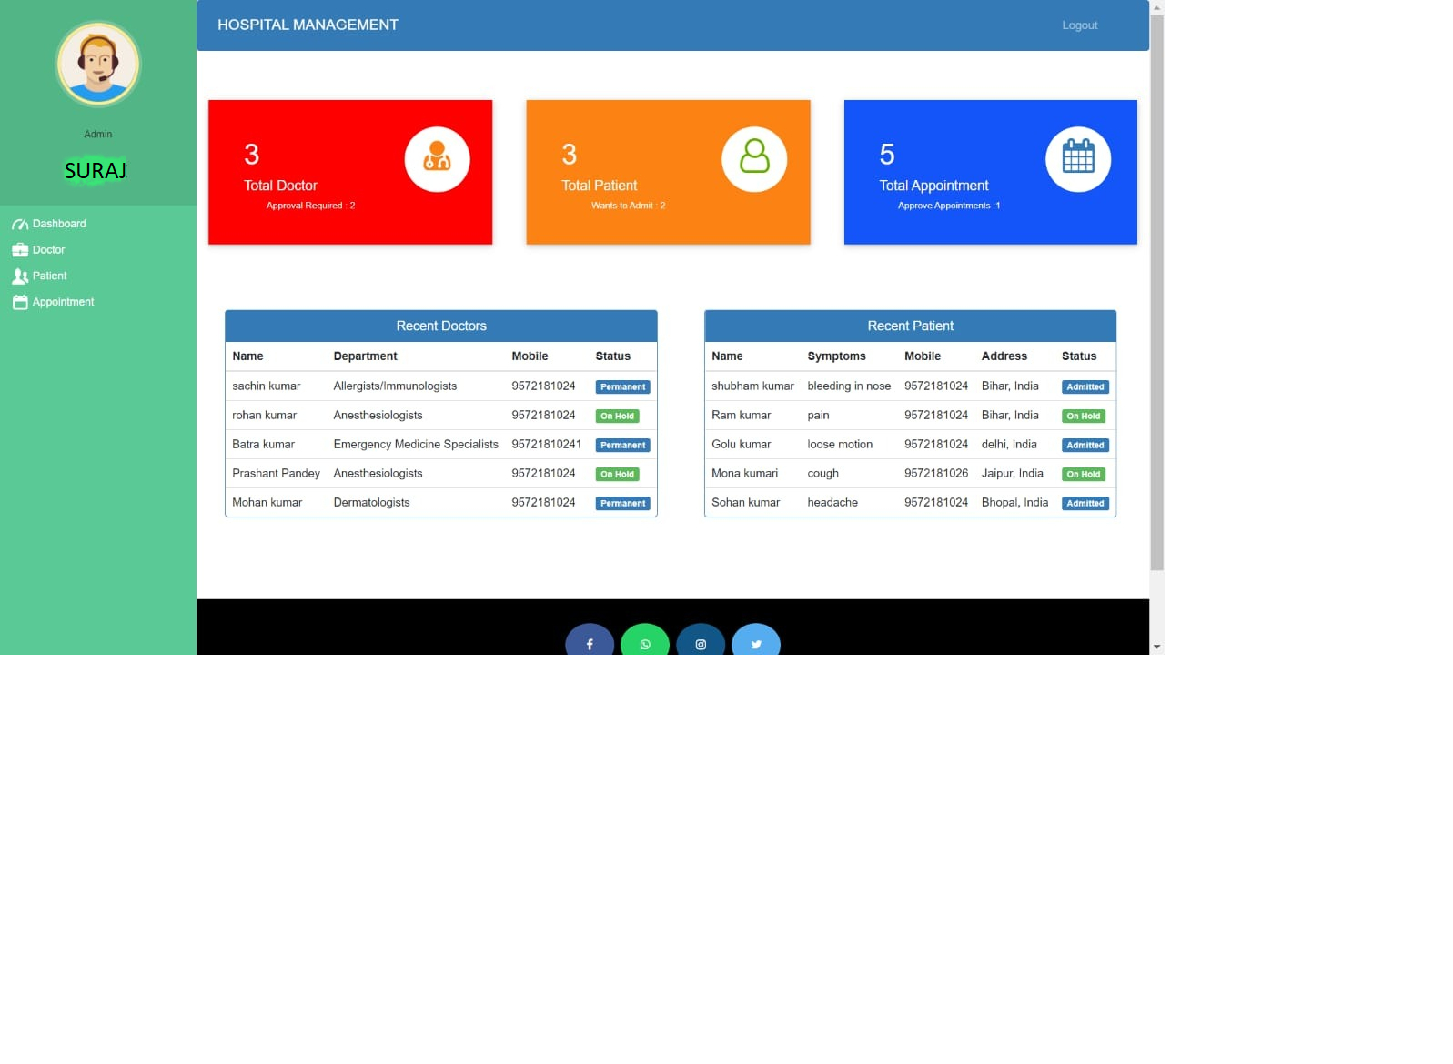

* **INVOICE**

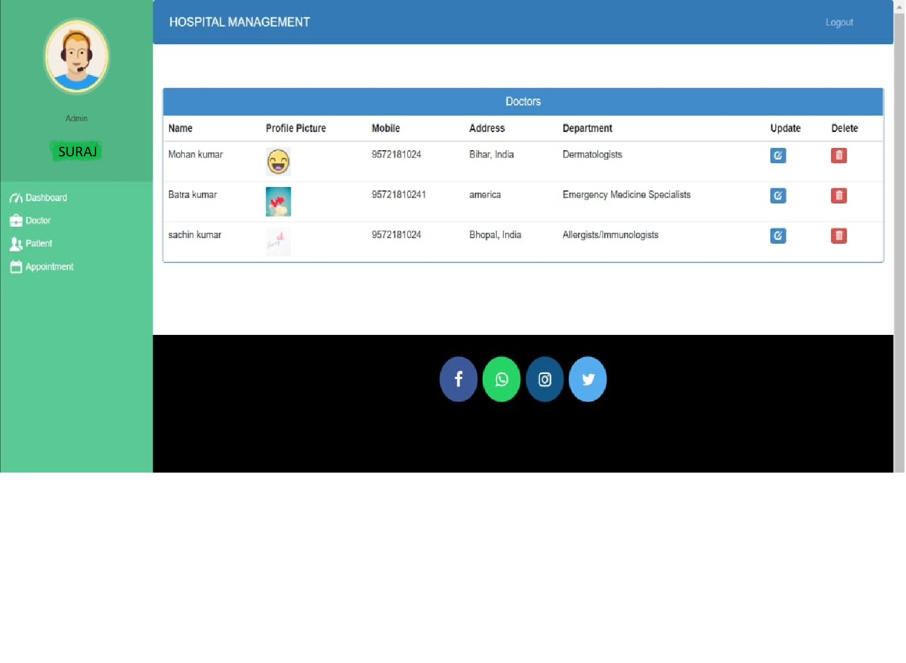

* **DOCTOR LIST**



**6.2 USER DOCUMENTATION**

**User manual of Hospital Management System**

• Login and make basic admin account

Before Enter to the system the user must need basic Admiration user login information to login to system. If you do not have user account, you can simply click on register here for mage user account.

User must file the all the fields in registration from after submitting valid data to registration.

User can simply enter data to login form and can enter to software main menu.

In the main menu, you can use the navigation bar or navigate buttons to navigate around the application.

After the main steps, before working with system make super admin account is the best way to start system.

• Setup super user account

To make super admin account user must needs to top level admin. You can create super admin

account by clicking Super admin account from navigation bar.

After entering to super admin function user need top level admin username and password to

login to create super admin account.

USERNAME = Admin

PASSWORD = Password

After adding login information of top level admin account, you can go to top level admin account

Options for top level admin function

• Super Admin Options

• Insert super admin.

In insert super administration user able to make super administration account, making

super administration account same as basic admin account creation.

• **Delete Super administration**

In Delete super administration top level user can delete super admin account.

• **Basic Admin Options**

• **Insert Basic Admin**

In insert Basic administration user able to make Basic administration account.

• **Delete Basic Admin**

In Delete Basic administration top level user can delete super admin account.

Both Super Admin Options and Basic Admin Options has same process.

After making Super Administration account user can use software. The usage of super administration account is it is needs to update or delete data in system.

• **Patient info.**

User can click and go to Patient info function by using navigation bar or main menu.

**Options of Patient info**

• **Patient Registration.**

In Patient Registration, user need to fill form with patient data and this form direct connects to OPD of hospital and user need to select OPD doctor for patient.

Figure 1 : Patient Registration form.

In the patient, Registration form the Contact number needs to enter with 0. (Ex – 340000000)

Need to select OPD doctor, Gender and Blood group of Patient.

• **Patient Information.**

Patient Information, this function can view all Patient of Hospital. It shows Patient name, OPD doctor Name and Blood Group.

By clicking More Information in OPD doctor column user can view information of doctor.

By clicking Make OPD invoice user can make invoice for patient.

By clicking Admit to Hospital user can admit patient to Hospital.

After clicking Make OPD invoice user can see new tab with forum user needs to insert medical charge and Doctor Charge. After inserting data user can print it by using patient invoice function.

After clicking Admit to Hospital user can see new tab with forum user needs to Disease and Room number. After inserting data user can remove patient form Admitted Patient function.

• **Patient Search.**

Patient Search function able user to find some advanced information about Patient. In Patient Search user need to insert registration number, Mobile number, Emil, first name or blood group in search box, by click search button without inserting data it shows all data in system about patients.• Patient information Edit and Delete.

To work with Patient information, Edit and Delete user need a super user account. By clicking Patient Information Edit and Delete form tab it shows login form again, user needs to insert super user login information. After login, it shows interface with search bar user can search user by inserting registration number, Mobile number, Emil, first name or blood group in search box.

By entering search value to search box user can get results like figure 72. It has two options Update and Delete. By clicking on Delete it simply delete the record of Patient.

By pressing update use can update patient information.

After clicking update system shows registration form with previous values of patient after entering new values to form user need to active update button by selectin “Enable Fields” form Active Fields selection. After select user can update patient information.

To go back user needs to press logout, to logout user can click on logout text form navigation bar and after login out to work with other functions user needs to insert basic administration account login information again.

NOTICE: Staff info function works same as Patient info function

• **Patient Invoices.**

Patient Invoices function can view and print both OPD and ADMITED PATIENT invoices.

By pressing “View” user can view patient invoice and by click on Print button on new patient invoice user can print the invoice. Both OPD and Admitted patient invoices work as same.

• **Room Availability.**

In this function user, can view available and unavailable room and user can select doctor in charge the room.

Room availability has two functions, Grid view and table view, in grid view user can see available and un available rooms in colors.

• In green = Available rooms

• In red = Un available rooms

In table view by pressing “Update room information” user can set doctor for room.

**• Admit Patient Information**

In this function user, can view admitted patients and user can discharge patient by clicking “Remove form room”.

After clicking “Remove from Room” there is no turning back, it shows invoice forum and discharge patient form hospital.

In admitted patient invoice user need to insert Medicine Charge, Doctor Charge and Count of Days to forum. After submitting user can view and print invoice form Patient invoice function.

**CHAPTER NO. 7**

**CONCLUSIONS**

**7.1 CONCLUSION**

In Conclusion, from a proper analysis and assessment of the designed system, it can be safely conclude that the system is an efficient, usable and reliable records management system. It is working properly and adequately meets the minimum expectations that were set for it initially. The new system is expected to give benefits increased overall productivity, performance and efficient records management.

**7.1.1 SIGNIFICANCE**

The health system is one of essential socio-economic activities; therefore, it requires rational and effective management. For this, it is necessary to have a tool that allows adequate control of the information generated in health institutions.

Hospitals, as the main actors of the health system, generate an essential volume of information, but in most cases, it is dispersed or not available in the necessary time and manner.

In recent years, health information systems have helped improve the quality of life of people in all sectors of our society, so it is inevitable to adhere to this dizzying technological career. Currently, clinical and administrative management of hospitals and health centers is possible through a single platform, with the support of cutting-edge technology, developed to optimize the processes that allow the operation of organizations dedicated to treating patients in any branch of the medicine.

[Hospital management systems](https://www.adroitinfosystems.com/products/ehospital-systems) allows us the ability to optimize and digitize all the processes within the institution, which will help to improve customer service, reduce process costs, streamline the search of medical records, bills, patients, doctors, etc.; thus, having a database of each module implemented.

A hospital management system is a web system developed for companies that wish to manage their processes, implementing modules for each of the required areas. It is essential to mention that the information is controlled by trained personnel. Computer technology is only a tool that allows us to perfect the inveterate use of paper records (notebooks, index cards, diaries, bibliographies, record books), or more recently, cassettes or video cassettes. A PC only collects and processes data; it is the individual that acquires information.

**7.2 LIMITATION**

[Hospital Management System](https://mocdoc.in/blog/a-detailed-view-of-hospital-information-system-his) is being used for decades. Most of the hospitals in India make use of HMS but they face certain challenges in implementing it. Among them,  technical and human challenges are considered to be the complicated factors while implementing HMS.

**How can you face the challenges while implementing HMS?**

The HMS system helps to manage every information about the patients like their personal data, comprehensive medical data, previous medical histories along with their diagnoses, treatments, investigations and other medical decisions. Apart from that, HMS help in improving the safety, quality as well as one of the most affordable options available in the healthcare industry.

Despite their benefits, the healthcare industry faces many challenges. Implementation of HMS still fails in some hospitals due to the barriers.

**Few Challenging problems that you face while implementing HMS**

**Human Challenges:**

* While considering the human factors, they include Awareness of HMS advantages & importance.
* In general, Experience, and knowledge of using computer applications.
* Impressions and Beliefs regarding HMS and making use of them efficiently.
* The researchers in a study have identified three main human challenges that are being a barrier in adopting the HMS in healthcare industries namely.
* Shortage of professional healthcare faculty who have in-depth knowledge of HMS and other similar technologies.
* Poor acceptance of HMS Software.
* Shortage of health informatics professionals who are well capable of establishing and implementing the techniques.
* Another few significant problems for unsuccessful HMS implementation includes.
* Healthcare specialists nature, the lack of time allowed training and learning on making use of the HMS, the lack of healthcare professional support, motivation, and more.
* Many studies illustrate that HMS needs more effort, time, adds more works. There are high chances of HMS to get slow down and cause a decrease in productivity.

**Technical Challenges:**

Other few technical challenges that fail the implementation of HMS in the healthcare industry includes Networks and computer have different maintenance problems, lack of no standards for Data entry and data retrieval, difficulties in training users technically to use HMS.

**7.3 FUTURE SCOPE OF THE PROJECT**

This application avoids the manual work and the problems concerned with it. It is an easy way to obtain the information regarding the various travel services that are present in our System. We intend to develop the project by make it comprehensive all the aspect of the hospital management like the add birth and death records, make the system ask patient for payment (bill) when a patient resolve to departure after treatment another aspect of hospital. The next enhancement is, we will develop online services. That mean, if patient have any problems, he can send his problem to the doctor through internet from his home then doctor will send reply to him In this patients have some login name and password. The doctor can ask opinion of a doctor in another hospital or elsewhere the case of certain.

**CHAPTER NO .8**

**REFERENCES**

**REFERENCES**

* **[https://www.academia.edu/](https://www.wikipedia.org)**
* **<https://github.com>**
* **<https://www.slideshare.net>**
* **[https://www.ncbi.com](http://www.google.com)**
* **[https://www.researchgate.com](http://www.youtube.com)**